**What is Amazon Machine Image (AMI)?**

The Amazon Machine Images are like templates that are configured using an operating system, an application server, and any additional application required to deliver a service or a part of it.

**Characteristics of AMI**

AMI has the following characteristics.

1. Region

2. Operating System(os)

3. Architecture (32-bit or 64-bit)

4. Launch Permissions

5. Storage for the root device

While choosing an AMI for our need we will take these parameters into consideration.

Among all these parameters **Region**, **OS**, **Architecture** needs less attention to study.

But, **Launch Permissions** and **Storage for the root device** needs more attention of study.

**Launch permissions:**

While we are launching a new EC2 instance 1st step we do is selecting AMI. We are given a list of Amazon Machine Images (AMI) to choose.

But sometimes we need our own customized Amazon Machine Image (AMI) to launch the instance. AWS has given feasibility to create our own Amazon Machine Images (AMI).

As the owner of AMI, we can determine its availability by specifying launch permissions.

There are 3 types of launch permissions.

1. public =🡺 Grants launch permissions to all AWS Accounts.

2. explicit =🡺 Grants launch permissions to specific AWS Accounts.

3. implicit =🡺 Grants launch permissions to no one except him.

**Storage for the root device:**

Amazon Machine Images (AMI’s) are classified into 2 types based on Storage for the root device.

1. Backed by Amazon EBS (Default one).

2. Backed by Instance store.

When we compare both, EBS Backed AMIs are more efficient, cost effective and provide more data persistence.

| **Characteristic** | **Amazon EBS-backed AMI** | **Amazon instance store-backed AMI** |
| --- | --- | --- |
| Boot time for an instance | Usually less than 1 minute | Usually less than 5 minutes |
| Size limit for a root device | 16 TiB | 10 GiB |
| Root device volume | Amazon EBS volume | Instance store volume |
| Data persistence | By default, the root volume is deleted when the instance terminates. * Data on any other Amazon EBS volumes persists after instance termination by default. | Data on any instance store volumes persists only during the life of the instance. |
| Modifications | The instance type, kernel, RAM disk, and user data can be changed while the instance is stopped. | Instance attributes are fixed for the life of an instance. |
| Charges | You're charged for instance usage, Amazon EBS volume usage, and storing your AMI as an Amazon EBS snapshot. | You're charged for instance usage and storing your AMI in Amazon S3. |
| AMI creation/bundling | Uses a single command/call | Requires installation and use of AMI tools |
| Stopped state | Can be in a stopped state. Even when the instance is stopped and not running, the root volume is persisted in Amazon EBS | Cannot be in stopped state; instances are running or terminated |

**Instance stages in Instance store Backed AMI**

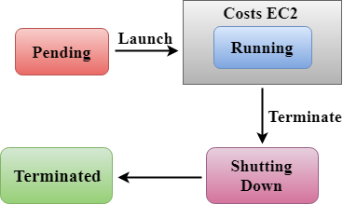

Here we don’t have the chance to stop and restart the instance. If we want to stop the instance only thing, we can do is terminating the instance. If terminate the instance data will be deleted.

if you want to run an instance for 4 hours a day and it would cost you 10 cents per hour. In instance store, my instance would be running 24 hrs a day as it has no stopped state. Therefore, it would cost 72 dollars a month.

**Instance stages in EBS Backed AMI**

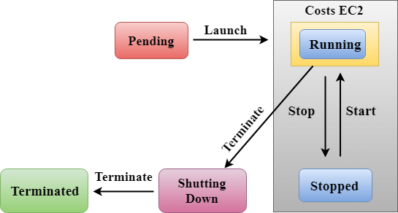

Here we have the feasibility to stop and start the instance so, if we want to run the instance 4hrs in a day, we can keep the instance in stop mode for remaining 20 hrs. amazon will charge for the instance running hours only (i.e., 4hrs).

if you want to run an instance for 4 hours a day and it would cost you 10 cents per hour. In EBS - backed instance, an instance will run for 4 hours as it has stopped state as well. So, it would cost 40 cents a day. The total running cost of an instance would be 12 dollars in a month.

The pricing cost of EBS is very less. let's say that you provision a 2000 GB volume for 12 hours (43,200 seconds) in a 30-day month.

In a region that charges $0.10 per GB-month, you would be charged $3.33 for the volume ($0.10 per GB-month * 2000 GB * 43,200 seconds / (86,400 seconds/day * 30 day-month)).

The total cost taken by this instance is volume cost + running cost which is equal to 15.33 dollars/month.

So, finally EBS Backed AMIs are more efficient, cost effective and more data persistence.

**Note:** Amazon EBS-backed instance root volumes have DeleteOnTermination flag set to true by default.

**AMI lifecycle:**

The following diagram summarizes the AMI lifecycle. After you create and register an AMI, you can use it to launch new instances. (You can also launch instances from an AMI if the AMI owner grants you launch permissions.)

You can copy an AMI within the same Region or to different Regions.

When you no longer require an AMI, you can deregister it.


    The AMI lifecycle (create, register, launch, copy, deregister).
   